Alarm: (ID 17) Error Position Lift Table

This alarm occurs when the platform is not correctly positioned on the AGV’s back while the table is lifted.
figure
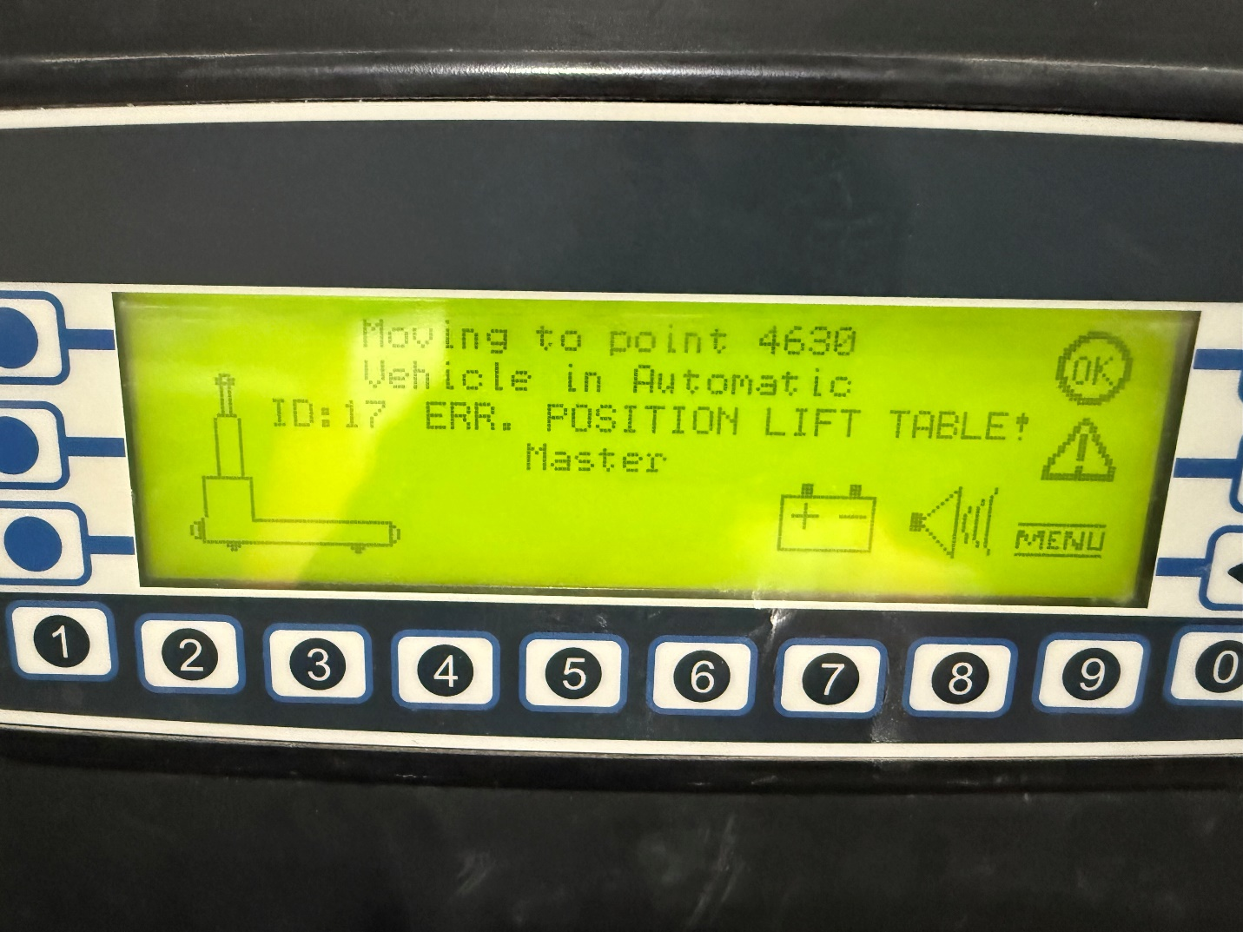

How To Fix:
To resolve:
- Ensure the platform is correctly positioned on the back of the AGV.
- Confirm that the table is lifted to its maximum height.
- Start the automatic sequence:
  - Automatic Mode
  - Press the Blue button
  - Press the Green button

